**Media Query:**

**there are four type of css media**

**All** : contain the all three type given below

**Print** : when anyone will print your website then how should it looks/ print on page

**Screen** : how should it response or looks on various devices/ screen

**Speech** : this facility is for the that persons which can’t see by eyside then they can hear the audio of the website screen by screen reader.

* here we will target only screen for the view of our website

**Syntax:**

@media screen and (max-width:1200px) {

Body{ background color: red }

}

@media screen and (max-width:1000px) {

Body{background color: blue }

}

@media screen and (max-width:800px) {

Body{ background color: brown}

}

@media screen and (max-width:600px) {

Body{

background color: yellow

}

}

**Print Media:**

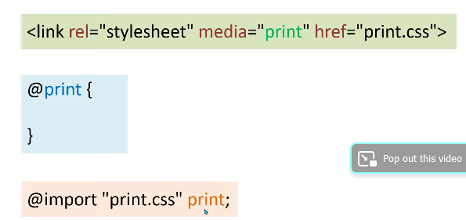

1. It is the way that we can use a file as a print media file we should create a new file and link

It as follows link tag.



* Use link tag and give the relation in **rel** attribute that is **stylesheet**
* Give the **file address in** **href**= attribute where we have design print media.
* Use **media** attribute and give the values of **print**
* The screen is the default value in media attribute not need to define separately

1. It is one more best way to use print media and screen media in only one combine file

@media print{

    p{

        font-family: Arial, Helvetica, sans-serif;

        line-height: 30px;

        background-color: gray;

    }

    h1{

        font-family: 'Gill Sans', 'Gill Sans MT', Calibri, 'Trebuchet MS', sans-serif;

        color: white;

        background-color: gray;

        -webkit-print-color-adjust:exact !important;

      print-color-adjust:exact !important;

        /* -moz-print-color-adjust:exact !important;

        print-color-adjust:exact !important */

    }

    p~p{

        display: none;

    }

}

1. We can use any print media file in a simple css file without using link tag with:

* Using